# HHS Job Opportunities Page Documentation

## Starting a New Airtable:

Any user can create a free Airtable account. Ideally, this account should have login credentials that can be shared by all those interested in adding/editing the job opportunities landing page for HHS.

You can also add and remove collaborators (other accounts) to the specific Airtable base (file) that hosts the data on the job opportunities in the case that the login credentials cannot be shared. More information on this can be found [here](https://support.airtable.com/docs/adding-a-base-collaborator#:~:text=A%20base%20collaborator%20has%20access,bases%20in%20an%20entire%20workspace.). A free airtable account can support 5 collaborators and 1,200 records in each base. More information on the features of the free plan can be found [here](https://airtable.com/pricing).

Below you can see a visual of the Airtable. The first row under home allows you to create a base. The easiest way to do this is to upload a file.

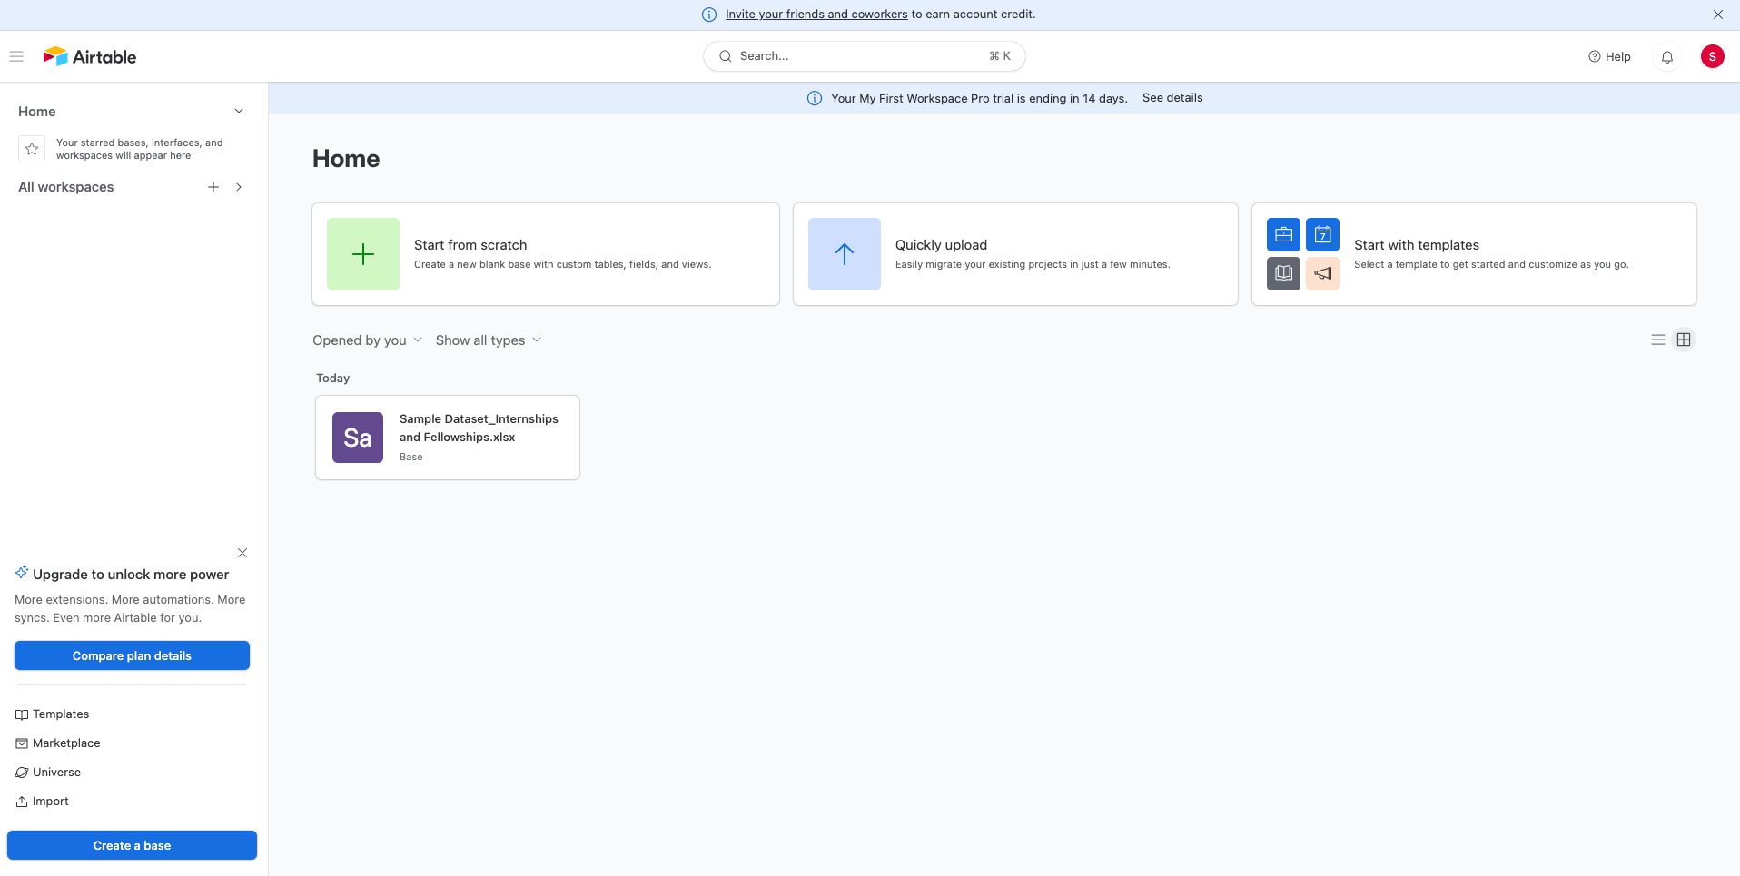

There are many file types that can be supported by Airtable’s upload feature (image below). We have used Microsoft .xlsx files in our demo. You can simply select the file you want to upload with all the job data and then select import.

**It is critical to note that the formatting of each column should follow a certain format - decided by HHS - to allow for easy updating of the table. Be sure to include a tags column to allow for easy filtering.**

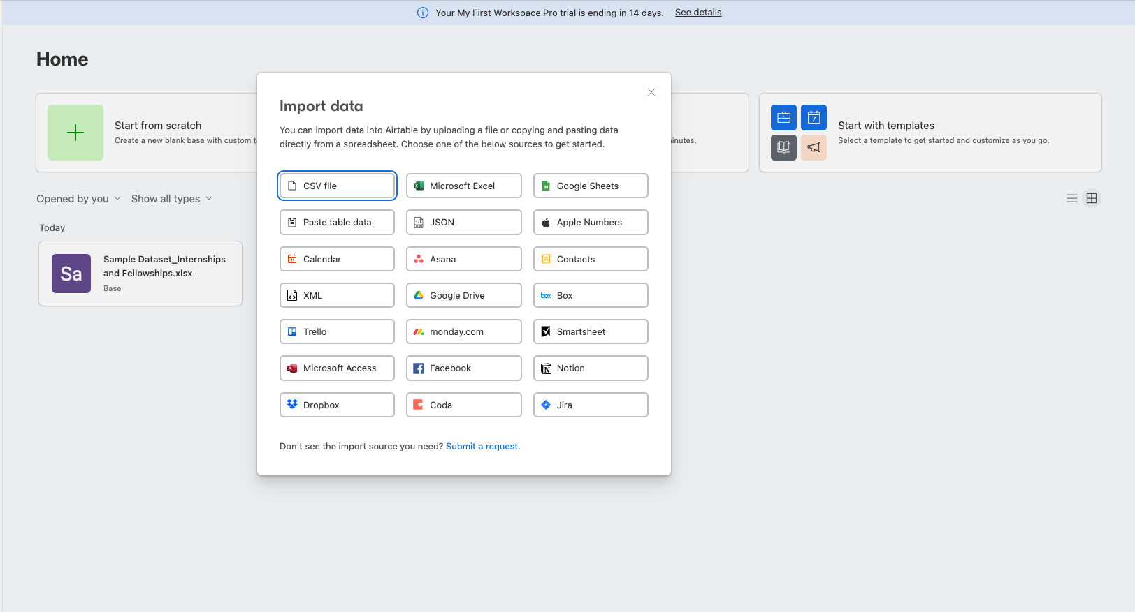

After uploading data to the base for the first time, you will reach this page:



This is inside your base. This table can now be shared and embedded into a static webpage. You can get the embed link for this specific base by selecting the *‘Share and sync’* button highlighted in pink in the image above.

From there you will be directed to the next page which provides you with the embed link and two different view types. Toggle the *‘Use card layout on desktop’* button to ‘on’. Please refer to the image below for clarification.



The lower half of the image shows a preview of the data in the base if it were to be embedded into a desktop or mobile view. You can then copy the embed code link to embed this file into the html file that is hosting the static page.

## Adding More Jobs to a New Base

If you would like to edit the jobs available by creating a completely new Airtable with all the job data, you will need to follow the steps listed in Starting an Airtable. This will result in you needing to change the embedded link on the static page.

Alternatively, you can follow the steps below to add and remove jobs on the pre-existing base. This results in no changes needing to be made to the html file or updating of the embed link.

## Adding More Jobs to the Same Base

If you would like to add more jobs to the airtable, you can simply do so by editing the pre-existing airtable that is embedded in the static page. This way, when you make updates to the airtable, you also make immediate edits to the static page.

Navigate to the base page that hosts the embedded Airtable and select the *‘Add or Import’* button as shown below.

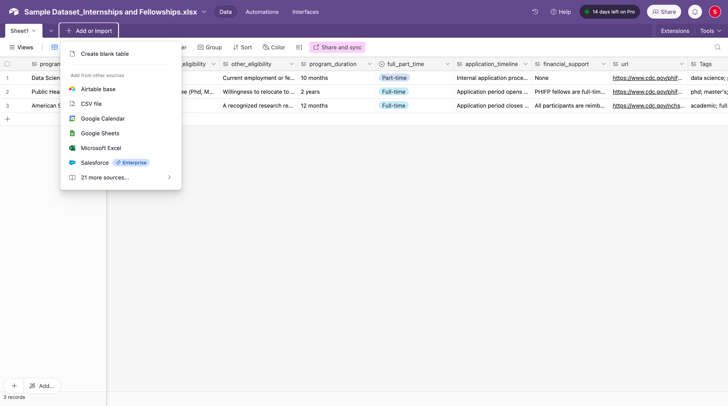

When you import to this airtable, import a file that has ***only*** the new jobs you want to add. After you select upload, choose to import the file into the pre-existing sheet in the base. This way you will not need to change the embed link on the HTML file hosting the Airtable.

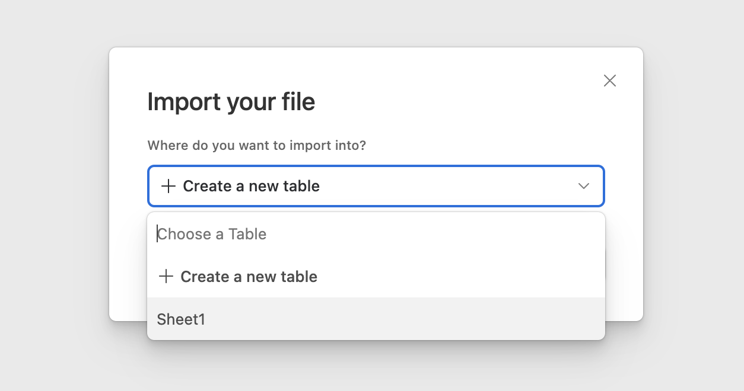

**It is crucial to keep your uploaded file format (headers) consistent with the pre-existing base format.**

After you finish uploading the file, you will see all the new jobs uploaded into your base. You may need to delete a row if the header of the file accidentally formats itself as a row in the table.

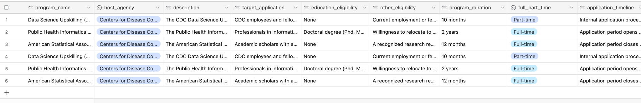

## Deleting Jobs From a Base

You can delete a row or job listing in the airtable by selecting all the rows you want to delete by selecting the number of the row on the left. You can then right click and delete selected rows.

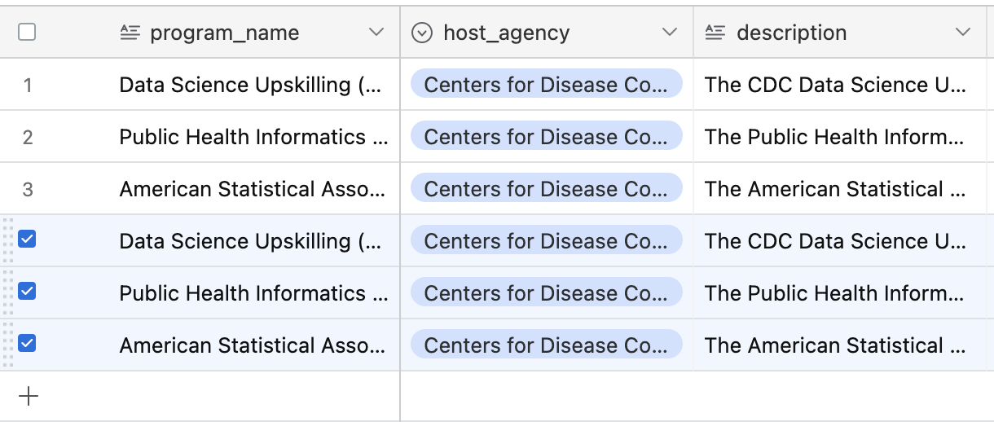

As long as all the changes you want to make are done on the Base which is embedded on the static page, all changes will be immediately visible on the static page as well. Any changes made on a new base ***MUST***be re-embedded via the embed link onto the static page to accurately reflect the information.

# Navigating Embedded Airtables

The embedded airtable is a great way to easily look through data. The video below shows you how to use the filtering tool to easily navigate through the airtable. (double click on the video and play from drawing)



As you can see, Tags are the easiest way for a user to search through and filter the job opportunities. Thus having clear and accurate tags is very important for usability.

# Frequently Asked Questions

## How long will it take to add to the airtable?

Adding to the airtable is extremely fast and can be done within minutes. As long as your edits are made on the base that is currently being hosted on the website, the changes will automatically be reflected on the website as you change your base.

If a new base is made (a new project file or sheet), then you will need to have the link for the new base embedded into the website to accurately reflect the information on the job opportunities.

## Who to contact for support?

To make changes to the web page, please contact [xxxx@xxx.com](mailto:xxxx@xxx.com) for support.

## Who to contact to make suggestions - feedback?

You can contact the HHS team responsible for sharing and documenting all the current/available job opportunities

## How do I know if I can add a job opportunity?

You can add a job opportunity if you have been added to the active base as a collaborator or if you have the login credentials of the account that hosts the active base on Airtable. The host of this base is [xxxx@xxxx.com](mailto:xxxx@xxxx.com). Please contact them for any changes.

## How many jobs can be added to a base?

A free airtable account can support 5 collaborators and 1,200 records in each base. More information on the features of the free plan can be found [here](https://airtable.com/pricing).